Hambouer Site Plan Ideas

Home Page / Introduction to Hambouer:

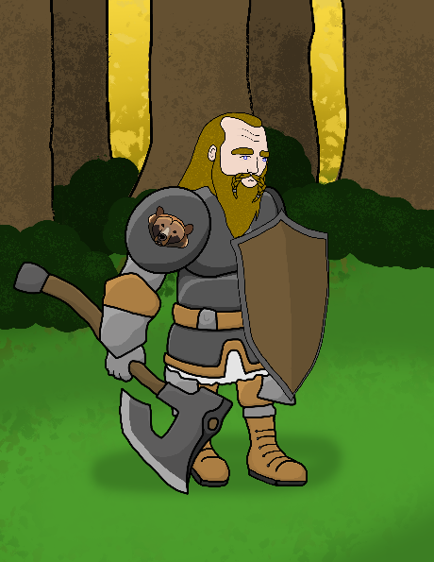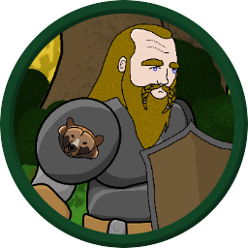

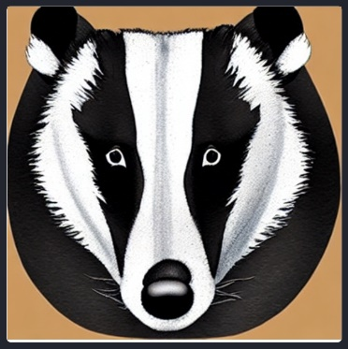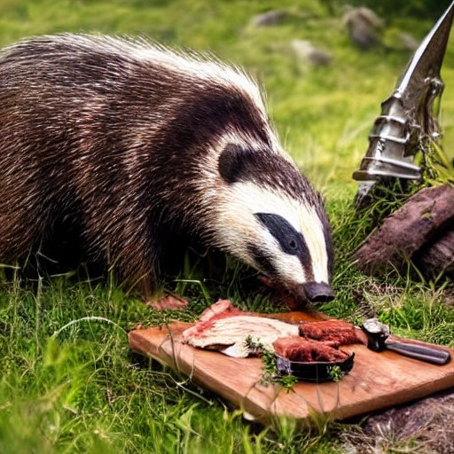

Character data sheet information, Hambouer is a Male Dwarf Ranger, he is strong and dexterous, but not very good with words. Hambouer joined a chaotic band of adventurers with varying morals but coming together with the promise of gold. Hambouer is highly motivated by food, and is easily distracted by the smell of food. Hambouer is very proficient with travel both above and below ground, he is comfortable scaling mountains, and moving quietly through the forest. His favorite weapon is an axe, which he wields as both a tool and a weapon.

Once the adventurers were in the wilderness of Barovia the companions took things slow, not knowing where to go or what to do, but surrounded by the wilderness where Hambouer felt at home, he took some time by himself. While immersing himself in the sounds of the forest, Hambouer found himself face to face with a badger. Hambouer pulled out some of the food from his pack and offered it to the badger, and soon he and the badger had formed a connection. Hambouer named the badger melee, and took him back to camp. Melee is a close companion who stays by Hambouer’s side and helps him in battle, using claws and teeth, while Hambouer swings his axe.

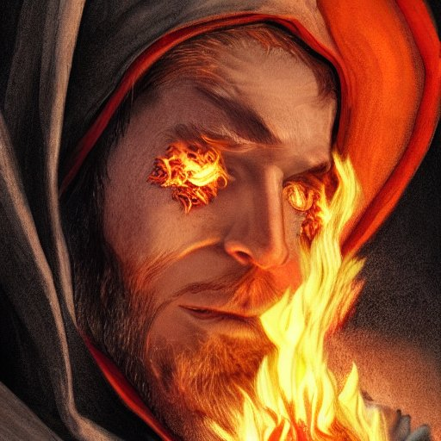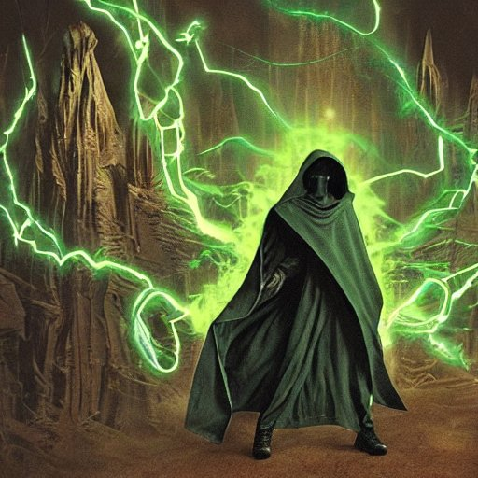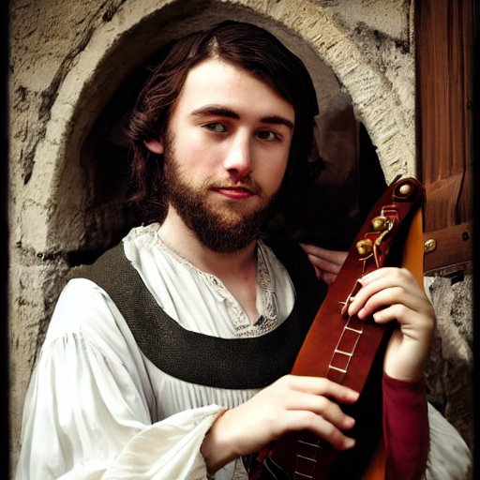

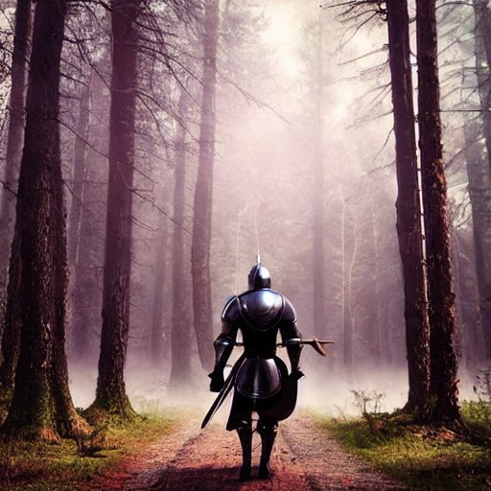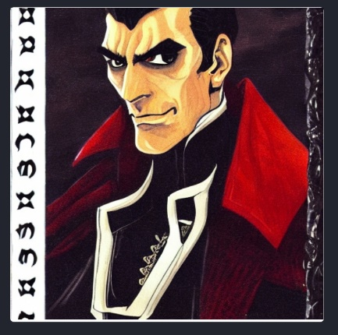

Companions: Cassius, carries a mace and dagger, very secretive but uses magic and can transform into a more powerful form. His favorite attack is an eldritch blast, and he prefers to attack from the rear, rarely facing an enemy directly. Sprodine, a bard, willing to steal for fun, with many magical abilities, always up to some form of mischief, but supports his companions when the times get tough. Uses his songs to invigorate his companions to make their attacks stronger, while using insults and jeers to hurt the enemies with words. Azlomorph, an eccentric wizard that is a pyromaniac, he has many magical abilities, and loves to watch the chaos unfold around him. While not the cause of the chaos, he is almost always involved in it, and often joins Sprodine in his mischief. Sir Aulfric, a late addition to the band after they had spent some time in Barovia, with a common goal, but very different morals. While the other companions love chaos, he is good at heart and unflinching in his values, often at conflict with the rest of the band. While allying himself with the companions, he is really searching for his friends from whom he was separated when he entered Barovia.

Character Adventures: The adventurers all meet at an inn, summoned by a mysterious person willing to pay well for them to retrieve something from what looks like an abandoned house on the edge of town. After the meeting the group splits, and Hambouer and Cassius watch the house for any signs of inhabitants, while Sprodine and Alzomorph have some fun robbing a local shop of any valuables they can. After they met and entered the abandoned house they began to explore. A mist formed outside the house and they were no longer able to leave. Soon a suit of bewitched armor came to life and began to attack the group. Hambouer took a position at the front, taking hits while dealing a good amount himself, while the rest of the group joined in. They continued to explore into the upper floors, finding a deed to a windmill, some scrolls, and various different items. While searching they entered a closet and a broom came to life and whacked one of the companions, Hambouer stepped in and was nearly killed in one hit from the broom. The others managed to pull him back out and close the door, and with some rest Hambouer recovered, but was left with a fear of brooms. There were paintings of a family throughout the house, and skeletons in different rooms. After more searching the adventurers found a secret winding staircase down to the basement, hidden in the third-floor master bedroom. Inside the basement there were signs of life, with cultists, in various passageways. After working their way through the cultists, they came upon a room with ghosts inside that were not able to be harmed. After entering the room, a monstrous beast, a shambling mass took shape and began to pursue them, the adventurers fled and as they entered the third floor again the house had come to life, with more traps and awakened objects. So Hambouer had a simple conclusion, instead of running through a house while being pursued, instead he could simply attach a rope to the balcony in the room nearby, and climb down the outside. When they escaped, they realized they were no longer at the edge of town, but in an entirely different land. Somehow, they had been transported to a land called Barovia. There were other various adventures, of fighting wolves, a mysterious Lord of the land of Barovia named Strahd, and a cloud of evil hanging over everyone.

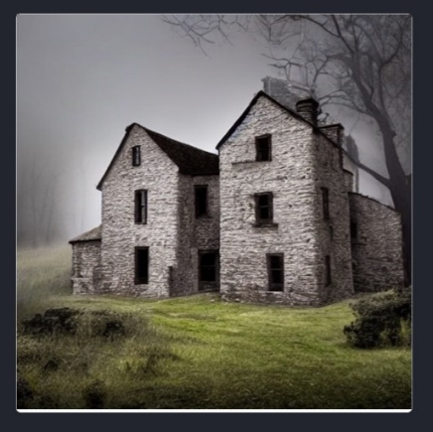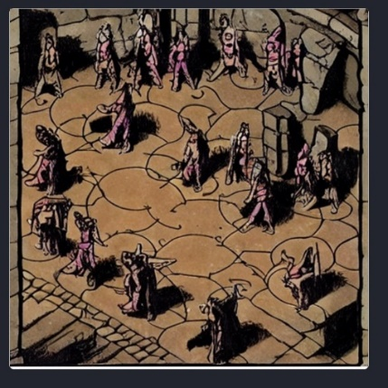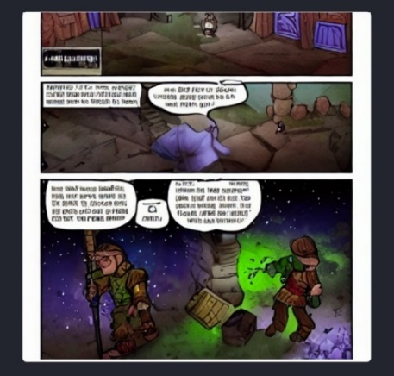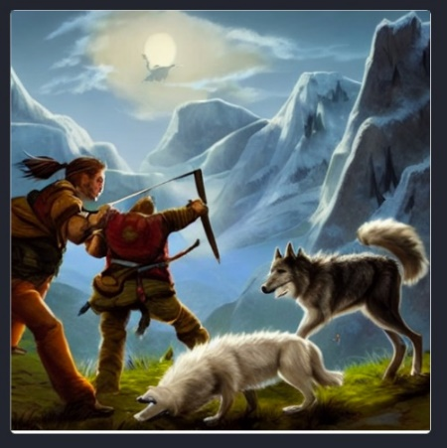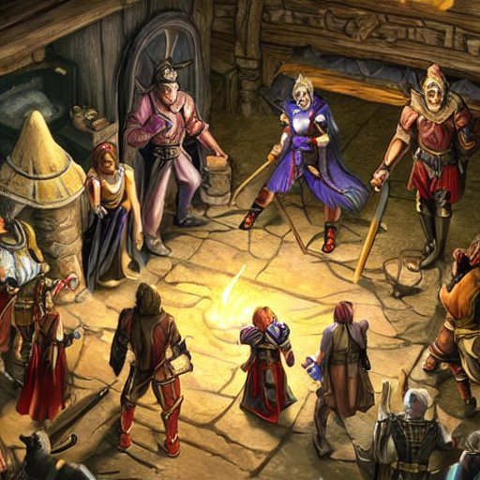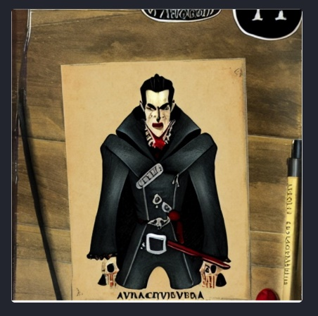

Once the adventurers were in the wilderness of Barovia they took things slow, not knowing where to go or what to do, but surrounded by the wilderness where Hambouer felt at home, he took some time by himself. While immersing himself in the sounds of the forest, Hambouer found himself face to face with a badger. Hambouer pulled out some of the food from his pack and offered it to the badger, and soon he and the badger had formed a connection. Hambouer named the badger melee, and took him back to camp. The adventurers were soon on their way again, and suddenly they heard howls. They were soon surrounded by a pack of six wolves, and the alpha seemed to be different, smarter, somehow. The wolves began their attack, and Hambouer pulled out his battle axe with Melee at his side. The group began to take the wolves down, one by one, in one case Hambouer dealt a great blow to a wolf, which was then finished off by a quick maul from Melee. After most of the wolves had died, the alpha transformed into a man. He was both handsome and terrifying, and he introduced himself as Strahd. Strahd was the ruler of Barovia, and he held it under a dark grasp where everyone was afraid of his power. Strahd commended the companions on their fighting, but warned them they would not make it out alive, and they were just his playthings. Then Strahd vanished, and the companions had a clear goal, find a way to defeat Strahd and leave the land of Barovia.

Character Design: The character design for Hambouer went through a few iterations. First I had to decide what kind of person Hambouer was, what he did for a living, a summary of his life and reasons for making the decisions he did. In the creation of a visual representation of Hambouer, I started with a few sketches, finally deciding on one. I then copied the image into paint, and did a simple design. From there I started on a better design of him, using photoshop with plenty of layers and detail, until I had something that felt right.

